26 Jan 2024

- Name Above All Names
- Hymn of the Savior
- Jesus paid it all
- There is a fountain

Name Above All Names (Sovereign Grace Music)

C#m7 A2 E B

[Verse 1]
E A2
From the brightness of His glory
E A2
Jesus the Son of God descends
E A2
Takes on the nature of a servant
E A2
Jesus, obedient to death
F#m7 B
The Father willed to crush Him
E B/D# C#m7
As a sacrifice for sin
F#m7 B
He satisfied God's justice
C#m7 A2 B
And in victory rose again

[Chorus]
C#m7 A2
You are highly exalted
E
Name above all names
B
Worthy of all praise
C#m7 A2
You are reigning in glory
E
Jesus, You're the King
B
Over everything

A2 E B
Exalted to the highest place
F#m7 A2 B C#
Given the name above all other names

C#m7 A2 E B

[Verse 2]
E A2
The tomb is empty, Christ has risen
E A2
Jesus, the Lamb, once crucified
E A2
The angels never cease to worship
E A2
Jesus, in heaven glorified
F#m7 B
To Him belongs the power
E B/D# C#m7
The wisdom, might, and strength
F#m7 B
All glory and dominion
C#m7 A2 B
To the Lord of every age

CHORUS

[Bridge]
A2
Our knees will bow
C#m7
Our tongues proclaim
A2 E
That You are Lord of all x2

CHORUS

Hymn of the Saviour: Emu Music
Keys intro
[Intro]
F Am C2 C2

[Verse 1]
Am F
From the chaos of darkness
C G
Your word shaped the earth
Am F C
In your image a people made
Am F
But we traded perfection
C G
The truth for a lie
Am F C
And your glory was veiled in shame

[Verse 2]
F C
But a promise made
G Am
A blessing you gave
F C G
To a people of your name
F C
For this broken world
Em Am
A saviour foretold
F G
To bear all our grief and pain

F Am C C
F Am C C

[Verse 3] Build Up
Am F
When the heavenly saviour
C G
Descended his throne
Am F C
All my sin on his shoulders laid
Am F
And to win our redemption
C G
He suffered and died
Am F C
For the sake of my guilt and shame

[Verse 4]
F C
Oh the price he paid
G Am
In taking my place
F C G
so that death was overcome
F C
For the king of love
Em Am
Burst forth from the grave
F G
Proclaiming the victory won

F Am C C
F Am C C

[Verse 5] (Soft)
Am F
At the end of the ages
C G
The world passed away
Am F C
I will gaze on my saviour's face
Am F
When my heart is perfected
C G
Free from my sin
Am F C (build)
I will rest in your glorious grace
Build to top
[Verse 6]
F C
For the song we raise
G Am
The works of our hands
F C G
Are in service of the king
F C
When a thousand tounges
Em Am
Cry "Glory to God"
F G F
Forever his praise we'll sing
F C
For the song we raise
G Am
The works of our hands
F C G
Are in service of the king
F C
When a thousand tounges
Em Am
Cry "Glory to God"
F G Am
Forever his praise we'll sing
F G F
Forever his praise we'll sing
Am C C
F Am C End

Just The Way God Wanted Us To Be

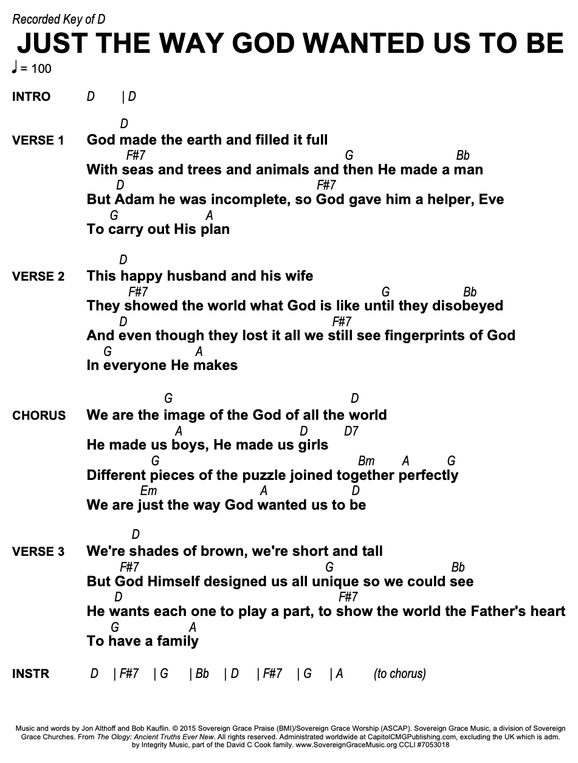
Jesus paid it all

JESUS PAID IT ALL

Intro C F Dm (C/E) F x2

Verse 1:
C Am
I hear the Saviour say
F C
Thy strength indeed is small.
(B) Am F
Child of weakness watch and pray
C G C
Find in me thine all in all.

Chorus:
C Am
Jesus paid it all.
C G
All to Him I owe.
C F C/E Dm
Sin had left a crimson stain,
C G C
He washed it white as snow.

C F Dm (C/E) F

Verse 2:
C Am
Lord now indeed I find
F C
Thy power and thine alone
(B) Am F
Can change the lepers spots
C G C
And melt the heart of stone

Chorus x2:
C Am
Jesus paid it all.
C G
All to Him I owe.
C F C/E Dm
Sin had left a crimson stain,
C G C
He washed it white as snow.

C F Dm (C/E) F

Refrain:
C F
Oh praise the one who paid my debt
Dm C/E F
And raised this life up from the dead. (x4)

C F Dm (C/E) F

Verse 3:
C Am
And when before the throne
F C
I stand in him complete
(B) Am F
Jesus died my soul to save
C G C
My lips shall still repeat

Intro:
C E G A

THERE IS A FOUNTAIN (G77)
Em C G G

V1:
G C G
There is a fountain filled with blood
Em Am7 D7
Drawn from Immanuel’s veins,
G C G
And sinners plunged beneath that flood
G Am7 D7 G
Lose all their guilty stains:
G7 C
Lose all their guilty stains,
G Em7 Am7 D7
Lose all their guilty stains;
G C G
And sinners plunged beneath that flood
G Am7 D7 Em C G G
Lose all their guilty stains.

V2:
G C G
The dying thief rejoiced to see
Em Am7 D7
That fountain in his day.
G C G
And there may I, though vile as he,
G Am7 D7 G
Wash all my sins away:
G7 C
Wash all my sins away,
G Em7 Am7 D7
Wash all my sins away;
G C G
And there may I, though vile as he,
G Am7 D7 Em C G G
Wash all my sins away.

V3:
G C G
Dear dying Lamb, Thy precious blood
Em Am7 D7
Shall never lose its pow’r,
G C G
Till all the ransomed Church of God,
G Am7 D7 G
Be saved to sin no more:
G7 C
Be saved to sin no more,
G Em7 Am7 D7
Be saved to sin no more,
G C G
Till all the ransomed Church of God,
G Am7 D7 Em C G G
Be saved to sin no more.

V4:
G C G
E’er since by faith I saw the stream
Em Am7 D7
Thy flowing wounds supply,
G C G
Redeeming love has been my theme
G Am D G
And shall be till I die:
G7 C G Em Am D
And shall be till I die, and shall be till I die,
G C G
Redeeming love has been my theme
G Am D Em C
And shall be till I die.

